NAKO members

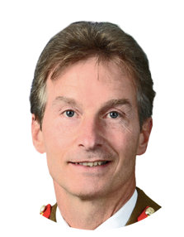 | Lieutenant General Timothy Evans CB CBE DSO: A 3 star General in the British Army and former Commander of the NATO Allied Rapid Reaction Corps.
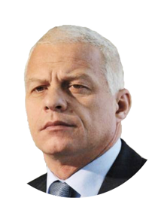 | Drago Kos (co-chair): Former Anti-Corruption Commissioner in Slovenia, Former Chair of GRECO, and current Chair of the OECD Working Group on Bribery. “I’ve been coming to Ukraine for 15 years and for the first time I feel the country is ready for real change – and it’s time to include the defence sector too.”
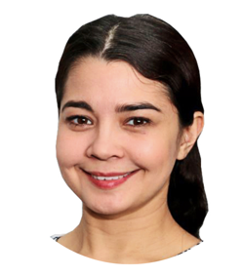 | Sevgil Musaeva: Editor in Chief of Ukrainska Pravda and author of investigative reports for Reuters, Forbes Ukraine, and the Organized Crime and Corruption Reporting Project. “I understood the problems of a weak defence sector when Crimea, my region, was annexed. So for me, it’s personal—I want to make the our armed forces more transparent and effective.”
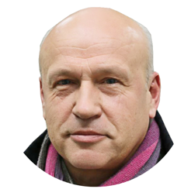 | Oleh Rybachuk (co-chair): Chairman of Centre UA, co-initiator of Chesno Campaign, and former Vice Prime Minister for European Integration and Chief of Staff to the president.
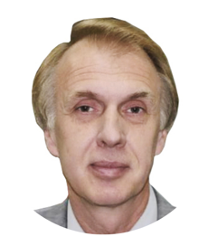 | Volodymyr Ogryzko: Former Minister of Foreign Affairs, First Deputy Secretary Defence and Security Council of Ukraine. “We badly need international support to fight corruption in Ukraine.”
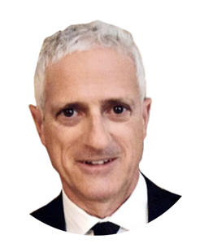 | James Wasserstrom: Former Head of Oversight of Public Utilities at the UN Mission in Kosovo, Senior Advisor on Anti-Corruption at the US Embassy Kabul, and strategy advisor and lead anti-corruption at the Special Inspector General for Afghanistan Reconstruction. “Countries in conflict are always immense opportunities for nefarious activities, especially corruption, profiteering, and egregious mismanagement. I look forward to this body tackling all of the above.”

