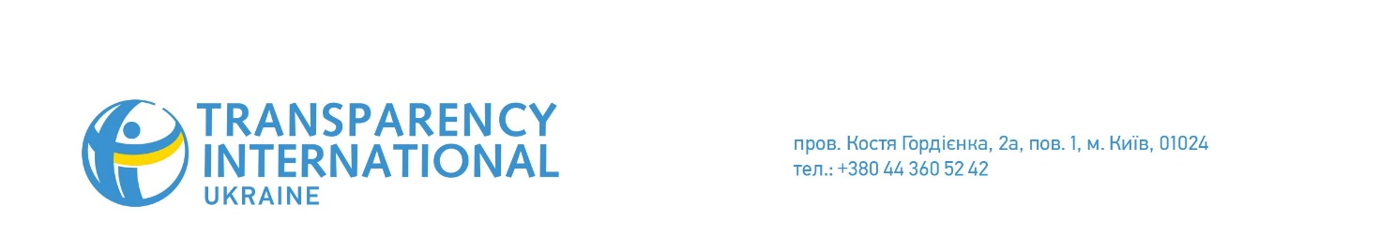
15.09.17
PRESS RELEASE
Reward or Praise? What Will Motivate Corruption Whistleblowers
In Ukraine, there are not enough examples of protection, recognition or rewarding people who report corruption. Are citizens in Ukraine, the Czech Republic and other countries of the world to disclose illegal demands and do they feel safe after it? These are the questions discussed by Transparency International representatives in Kyiv at the panel discussion “Corruption Whistleblowers. Foreign Practices and Ukrainian Circumstances.”
Across the world, the civil courage necessary to report instances of corruption is instilled in different ways. The European model considers corruption whistleblowing a duty of every concerned citizen, which is also encouraged emotionally. For instance, a whistleblower in Ireland was awarded the Person of the Year title. In the American model, corruption whistleblowers receive a compensation in the amount of 15-25% of any seized funds and fines for their effort and risks taken.
The Czech chapter of Transparency International believes that financial compensation turns a whistleblower into a stool pigeon. “If the whistleblower themselves or a company they represent suffer as a result of disclosing corruption, only then do they have the right to demand a refund for these losses and appropriate protection from the state,” states Ondřej Cakl, project coordinator at Transparency International Czech Republic. True, Czechs engage in corruption whistleblowing even without financial compensation. A research by Stenmark national agency in the Czech Republic reports that whistleblowers have a positive image in the Czech Republic: 69% of the surveyed consider them heroes.
CEDEM development director Tetiana Semiletko believes that praise can work as gratitude for anti-corruption activism as well. “In Ukraine, it is necessary to reduce citizens’ personal motivation to engage in bribery through educational campaigns and courses in educational institutions. Besides, there is an urgent need to create effective tools and communication channels to report corruption, as well as to provide whistleblowers with legal and physical protection.”
Ondřej Cakl showed the participants TI Czech Republic’s social campaign and a website for reporting corruption instances with a motto “We won’t allow corruption to become a sport!”: https://www.korupcniviceboj.cz/
It is essential to disseminate information on self-protection while reporting corruption; they have to do not only with prevention of negative consequences for whistleblowers but also with citizen’s general safety. “Under no circumstances send the information from your work computer or home WiFi network. Check that your anti-virus databases are up to date, for further protection, use Tor browser and cipher your emails with PGP,” explained Oleksandr Kalitenko, policy analysis expert at Transparency International Ukraine. You can find more advice on how to preserve safety and anonymity in the manual for corruption wihistleblowers recently preseted by CSO Trudovi Initsiatyvy, Solidarity Center and Transparency International Ukraine: http://vykryvachi.trudovi.org/
The panel discussion was organized by Transparency International Ukraine with the support of Office of Friedrich Naumann Foundation in Ukraine and Belarus. This is the fifth event within a joint educational project. In March, 2017, there was a lecture by Duncan Hames, Director of Policy at Transparency International UK. In April, 2017, discussion Media as a Tool to Combat Corruption was held with the participation of TI Lithuania’s executive director Sergejus Muravjovas. In May, it was followed by the discussion Conflict of Interest in EU Member Countries with the participation of Daniel Freund, Head of Advocacy EU Integrity at Transparency International. In June, there was the discussion How to Promote Integrity in Government Institutions, with the participation of TI Georgia Project Manager Erekle Urushadze.

