PRESS-RELEASE
06.11.2017
Why Do You Give Bribes? – ТІ Ukraine Started a New Communication Campaign
Provocative billboards with a businessman who admits he “gives because he is coerced into it,” students who “give because it’s become a habit,” and a patient who “gives to survive,” which evoke a sort of double entendre in Ukrainian*, appeared in 17 Ukrainian cities on November, 1. The stories of these characters who have to engage in corruption even though they don’t want to aired on TV and the radio.

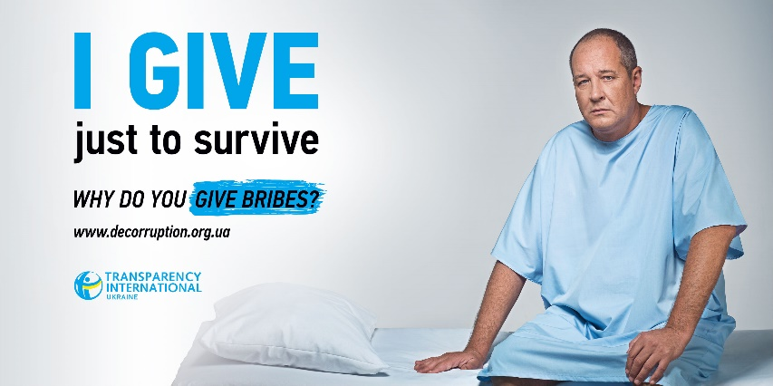
Based on the outcome of the opinion poll done by the Democratic Initiatives Foundation, about 25% of Ukrainians have given a bribe during the past year. What makes people support corruption instead of resisting it? After all, according to this research, about half the population consider bribes an unacceptable phenomenon, 44% - negative and only 9% believe it to be “a normal way to solve problems.” Transparency International Ukraine decided to bring up this issue and ask people – why do they give bribes and condone corruption?
“Four years now we are doing communication campaigns to draw Ukrainians’ attention to the problem of corruption and encourage them to reevaluate their own participation in it,” said Olha Tymchenko, head of communications department at TI Ukraine. “Our global goal is to change Ukrainians’ mentality, instill zero tolerance to corruption. Psychologists claim it will take fifteen years. The aim of this year’s campaign ‘I Don’t Give [Bribes]’ is to evoke the feeling of personal responsibility for condoning corruption. To shed light on the problem of petty corruption that tends to get swept under the carpet, comparing it to violence, and to ask Ukrainians – how do they explain bribery to themselves? To show to those who are brave and caring enough to fight against corruption that they are not alone, that what they are doing is important and useful and there are many of us.” The purpose of uniting positive stories was why TI Ukraine and the global TI movement initiated the international flashmob which will take place during November in social media with hashtags #ЯнеДаю #IDontBribe, where people will share their own stories when they encountered corruption and refused to engage in it.
The communication campaign I Don’t Give [Bribes] has been developed by the famous creative agency PROVID, which offered the best concept for the problem in question. Vlad Haliapa, associative creative director of PROVID and author of the idea, explains why the creative experts decided to awaken Ukrainians through provocation: “People don’t really enjoy paying attention to social advertising, especially the kind where they can recognize themselves. Like engaging in petty corruption. We are outraged about top-level bribery, yet keep giving bribes left and right. Of course, we don’t really talk about it, because it’s a little shameful and humiliating. So people may not pay attention to a reminder of petty corruption for their own peace of mind, but everyone pays attention to provocative, scandalous things. That is why we decided to ask people why they gave bribes using three heroes as examples. We just skipped the word ‘bribe.’ The message immediately gained double entendre, playing on the well-known fact that giving bribes is… shall we say, a little inappropriate and humiliating.”
The campaign consists of two waves. The first one provokes, brings up the problem, and leads people to the article on the communication platform www.decorruption.org.ua about the importance of personal resistance to corruption. The second wave will take place with the participation of famous Ukrainian poet Serhii Zhadan and popular TV presenter Tetiana Danylenko, who will broadcast the most incredible success stories from the flashmob.
The social campaign has been supported by numerous media partners who, too, care about the problem of corruption. They are the Ministry of Information Policy, LIGA.net portal and Ukrainska Pravda media website, Era FM radio, Hromadske Radio, radio Voice of Donbas, TAVR MEDIA radio group (Kiss FM, Radio Roks, Relax, Russkoye Radio Ukraina, Melodiya FM). Video teasers will be broadcast by Hromadske.tv, UA:Pershyi. TI Ukraine is thankful for their participation and support to Serhii Zhadan Charity Fund, photo studio Shoot Group Video&Photo Production. All information content has been developed by PROVID creative agency. Outdoor advertising will be located in 17 cities: Kyiv, Odesa, Dnipro, Zaporizhia, Khmelnytskyi, Kherson, Kharkiv, Lutsk, Kropyvnytskyi, Mykolaiv, Poltava, Sumy, Bila Tserkva, Chernihiv, Cherkasy, Rivne, Lviv.

This campaign was conducted by Transparency International Ukraine as part of its project implemented under the USAID/ENGAGE activity, which is funded by the United States Agency for International Development (USAID) and implemented by Pact. The contents of this campaign are the sole responsibility of Pact and its implementing partners and do not necessary reflect the views of USAID or the United States Government.

We encourage everyone to participate in the flashmob on social media and talk about their experience with resistance to corruption using hashtags #ЯнеДаю #IDontBribe. We also invite outdoor advertising operators and media to take part in our campaign.

*Translator note: the word ‘give’, when used without the object in Ukrainian, depending on the context, usually hints at frivolous sexual behavior.

#
Media contact: Olha Tymchenko, Head of Communications Department at Transparency International Ukraine  Cell: 050-352-96-18,  e-mail: tymchenko@ti-ukraine.org | Transparency International Ukraine is a national chapter of Transparency International, an anti-corruption NGO with over 90 national chapters; which operates in more than 100 countries. TI Ukraine’s mission is to limit the increase of corruption in Ukraine by promoting transparency, accountability, and integrity in both the public authorities and civil society. You can learn more about the organization’s activity on the website www.ti-ukraine.org

