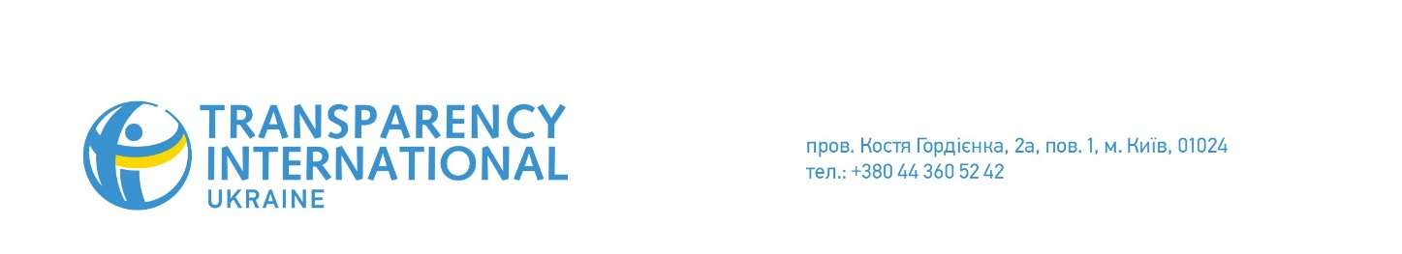
PRESS ANNOUNCEMENT
28.09.2017

Anti-Corruption Court: to Be or Not to Be? A Discussion in Lviv

DEJURE Foundation and Transparency International Ukraine are happy to invite lawyers, journalists, activists, judges and representatives of the local authorities to the expert discussion on the judicial reform and launch of the High Anti-Corruption Court in Ukraine.
The event will take place on October 3, 2017 at 10AM in Dnister hotel at Mateika st. 6, Lviv.
On September 25, the Supreme Council of Justice finished the review of candidates to the Supreme Court. Despite the fact that Public Integrity Council did not recommend 30 out of the 120 candidates for the position, the Supreme Council of Justice ended up not recommending only four. The President spoke highly of the competition process, even though, given the non-binding nature of Public Integrity Council's conclusions, many of the #НедоброчеснаТридцятка (Unscrupulous Thirty) can obtain a position in the Supreme Court.
Nothing has changed in the past three years: political forces with vested interest influence court decisions, and judges try to protect themselves from the reform. As the result, the society does not trust the current judicial system, while corrupt officials are still free. This is why there is a critical need for the High Anti-Corruption Court, which will hear cases investigated by the NABU.
How should the new institution function? How should the judges for the anti-corruption court be selected? How can the public and the media prevent unscrupulous candidates from obtaining positions in the Supreme Court of Ukraine? How can journalists and activists work together to purge the judiciary from questionable judges? These are the questions that will be answered in the course of the discussion.
Discussion participants:
• Mykhailo Zhernakov – director of DEJURE Foundation, member of Public Integrity Council, member of Council of Reanimation Package of Reforms;
• Taras Shepel – member of Public Integrity Council, co-founder of DEJURE;
• Iryna Shyba – DEJURE Foundation project manager;
• Maksym Kostetskyi – legal adviser of Transparency International Ukraine, manager of the Civil Support of the Launch of the Anti-Corruption Court project
To participate, please register by September 30 at: https://goo.gl/forms/syIu3x8mjWrZ48Gf1
On all logistical issues and to obtain journalist accreditation, please contact Maksym Kostetskyi at 0638874630.
Food and handouts will be provided by the organizers.
The event is supported by the Ministry of Foreign Affairs of the Czech Republic under the Transition Promotion Program. The information highlighted during the event may not reflect the official position of the Ministry of Foreign Affairs of the Czech Republic.

